18.83: a) See Problem 18.80. Because 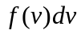 is the probability that a particle has a speed between 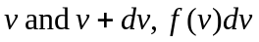 is the fraction of the particles that have speed in that range. The number of particles with speeds between 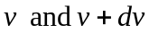 is therefore 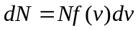 and

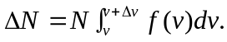

b) 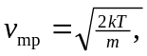 and

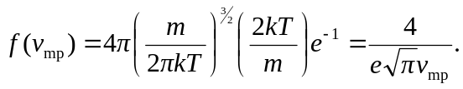

For oxygen gas at keeping an extra figure. c) Increasing by a factor of 7 changes d) Multiplying the temperature by a factor of 2 increases the most probable speed by a factor of 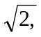 and the answers are decreased by 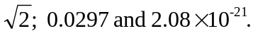 e) Similarly, when the temperature is one-half what it was parts (b) and (c), the fractions increase by 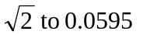 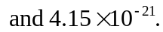 f) At lower temperatures, the distribution is more sharply peaked about the maximum (the most probable speed), as is shown in Fig. (18.20).

